**To perform a task on Jenkins**

1. Start Jenkins Dashboard.

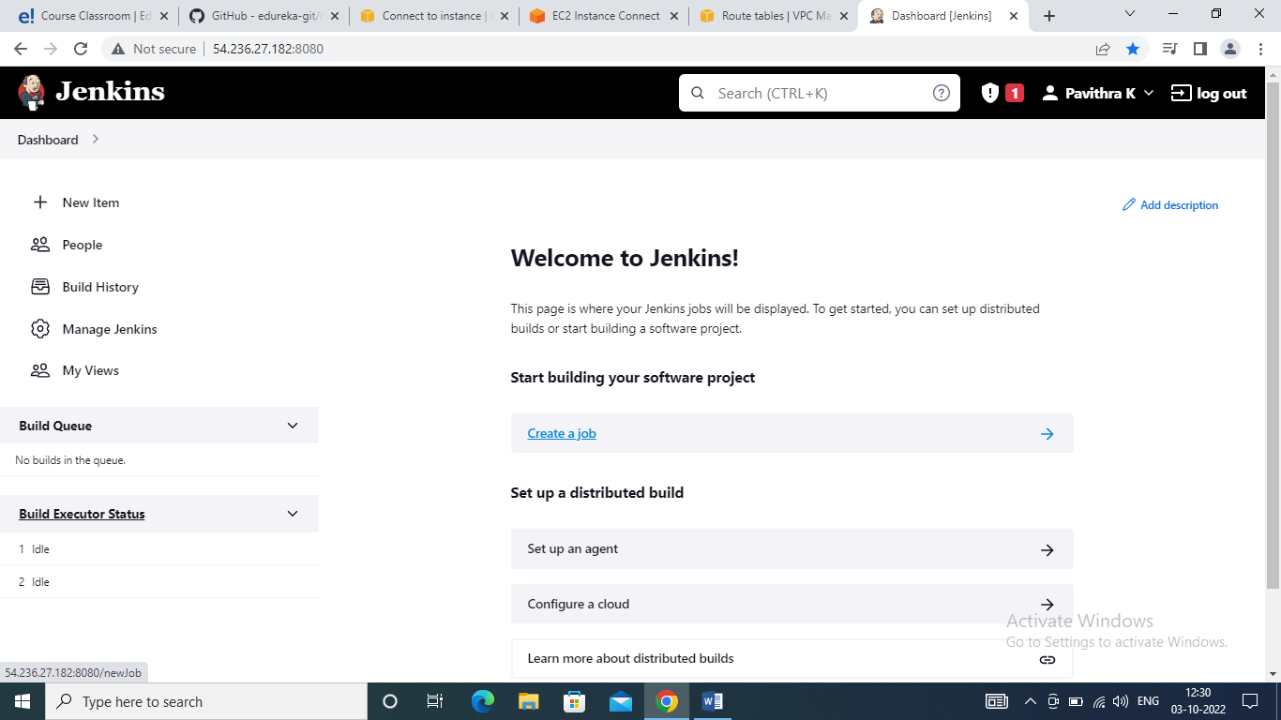

1. Create a new job – Freestyle, give it a name as CloneGitRepo

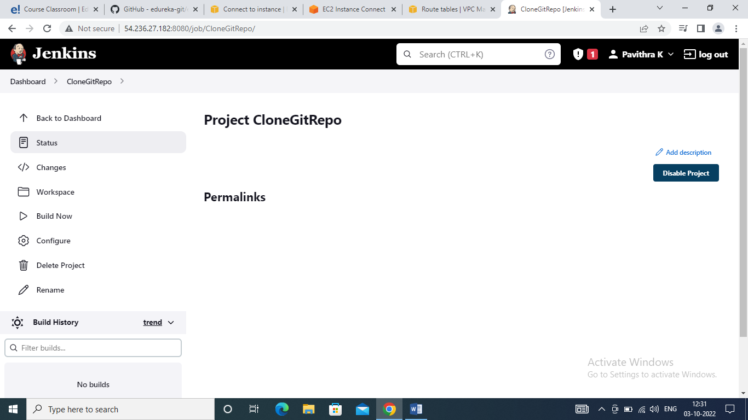

1. Select a git hub repository : <https://github.com/edureka-git/edureka.git>

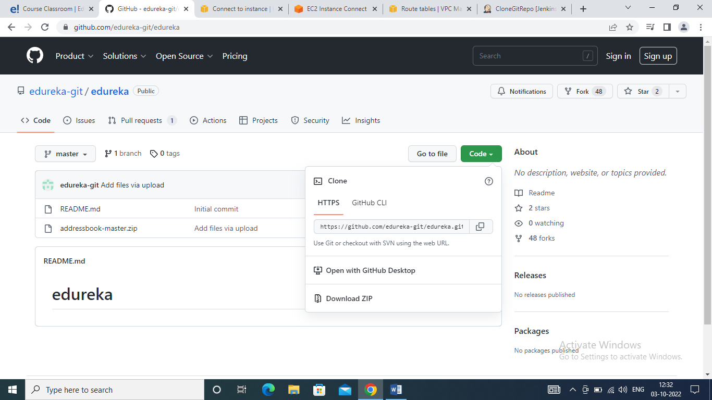

1. Add the repository in the freestyle job
2. Also add a custom workspace path as /tmp/workspace on the freestyle dashboard ➔ General Tab -> Advanced field

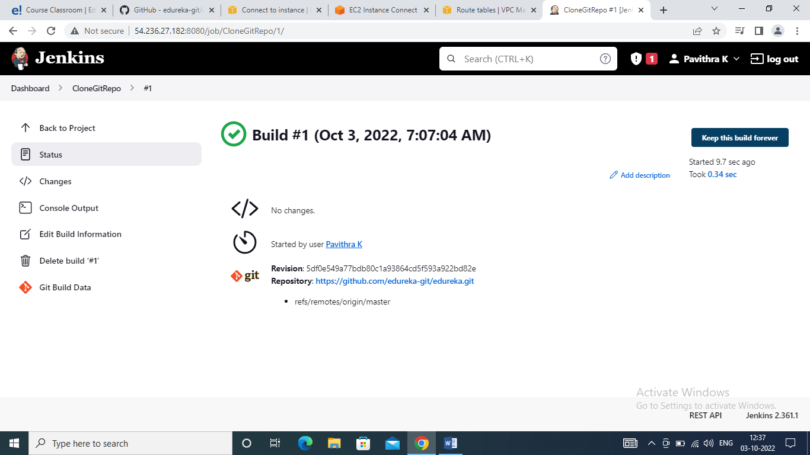

1. Build the job and check the files are pulled in the custom workspace

